

Instructions for Inverter DC (Pulse) Argon Arc Welding Machine

Model：WSM-400HD pro

WS-400HD pro

WSM-500HD pro

Version number：B2-2501

(PLEASE READ CAREFULLY BEFORE OPERATION)

Chengdu Huayuan Electric Equipment Co.,Ltd.

Safety Depends on You:
Huayuan arc welding and cutting equipment are designed and built with ample safety consideration. However, proper installing and operating the machine can increase your safety.
DO NOT INSTALL, OPERATE OR REPAIR THIS EQUIPMENT CASUALLY WITHOUT READING THIS MANUAL THROUGHOUT.

Special Attention (Very Important):

1. Be sure to avoid the welding machine falling down when it is placed on the gradient ground.
2. It’s forbidden unfreezing the pipeline by the welding machine.
3. The shield rank of this serias of welding machines is ip23s, so working in rain is not sutable.
4. The rated duty cycle of this welding machine is 35%, there is protection function when the machine is overloading used. When it’s protected and no power output, must wait and after the temperature back to normal, then use again.
5. When welding current is lower than 200A, the argon gas flow is 4-8L/min, when welding current is higher than 200A, the argon gas flow is 8-15L/min.
6.This welding machine's electromagnetic compatibility (EMC) classification is Class A.

Purchase Date：__________________
Serial Number： _________________
Machine Type： _________________
Purchase Place：_________________

  Cautions | Arc and arc rays can hurt.
Protect yourself and others from arc radiation and burns, keep children away from hazardous areas, and ensure that welding personnel possess health certificates issued by authoritative organizations.
Carefully read the following important reminders and thoroughly review the welding safety regulations issued by authoritative organizations. Ensure that the installation, operation, maintenance, and repair of welding and cutting machines are performed only by qualified professionals.

- 1.Electric shock：The circuit of the welding machine or cutting machine is open during operation. If exposed parts of the body simultaneously come into contact with the two electrode circuits of the welding machine's output, it may result in an electric shock accident, which can be life-threatening in severe cases. Users need to follow the below items to avoid electric shocks:
- The work area should be laid with dry and sufficiently large insulating materials. If conditions do not permit, prioritize using automatic or semi-automatic welding machines and DC welding machines.
- On automatic and semi-automatic welding machines, components such as the wire spool, wire feeder, contact tip, and welding torch are all electrified parts.
- Always be sure the work cable makes a good electrical connection with the metal being welded. The connection should be as close as possible to the area being welded.
- Guarantee the work or metal to be welded to a good electrical(earth) ground.
- Maintain the electrode holder, work clamp, welding cable and welding machine no damage, moisture, mold, or other such conditions. Replace damaged insulation.
- Never dip the electrode in water for cooling.
- Never simultaneously touch electrically “hot” parts of electrode holders connected to two welders, because voltage between the two can be the total of the open circuit voltage of both welders!
- When working above floor level, please do wear safety belt to avoid falling or losing balance on electric shock.
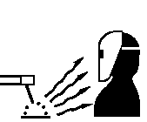
- 2.Arc ray: Use a shield to protect your eyes and skin from the rays of the arc when welding. Filter lens should conform to nation standards.
- Use suitable clothing made from durable flame-resistant material or canvas workwear to protect your skin and that of your helpers from the arc rays.
- Protect other nearby personnel with suitable, non-flammable screening and/or warn them not to watch the arc nor expose themselves to the arc rays or to hot spatter or metal.

- 3.Fumes and Gases: Welding may produce fumes and gases hazardous to health. Avoid breathing these fumes and gases. While working in limited room, exhaust to keep fumes and gases away from the breathing zone, or use the respirator. Do not weld in locations near chlorinated hydrocarbon vapors coming from degreasing, cleaning or spraying operations.The heat and rays of the arc can react with solvent vapors to form phosgene, a highly toxic gas, and other irritating products.
- Shielding gases used for arc welding can displace air and cause injury or death.
- Read and understand the manufacturer’s instructions for this equipment and the consumables to be used, including the material safety data sheet (MSDS) and follow your employer’s safety practices. Make sure they are asepsis and innocuity.
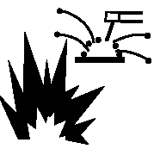
4.Spatter: Welding or cutting spatter can cause fire or explosion.
- Remove all materials and items that may combust, as welding spatter can reach these materials through very small openings. Protect all pipelines passing through the welding area, including hydraulic lines.
- Where high-compressed gases are to be used in the field, special precautions should be used to prevent explosion.
- When not welding, make certain that no electriferous part is touching the work piece or the work stage. Accidental contact can create a fire hazard.
- Do not weld containers or lines, which are not proved to be innocuity.
- Do not heat, cut or weld tanks, drums or containers until the proper steps have been taken to insure that such procedures will not cause flammable or toxic vapors from substances inside.
- Spatter might cause burn. Wear leather gloves, heavy shirt, cuffless trousers, high shoes and a cap over your hair to prevent from burning skin by spatter. Wear the ear shield when performing sideways or face up welding. Always wear safety glasses with side shields when being in a welding area.
- The welding cables should be as close to the welding area as possible, and the short, the better. Avoid welding cables going through the building framework, lifting chains, AC or DC cables of other welding machines and appliances. The welding current is strong enough to damage them while having short circuit with them.
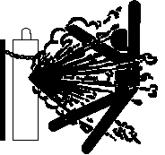
5.Cylinder：May explode if damaged.
  - Make sure that the gas in the storage cylinder is qualified for welding, and the decompression flowmeter, the adapter and the pipe are all in good condition.
  - Always keep cylinders in an upright position securely chained to an undercarriage or fixed support.
  - Be sure to put the cylinder in the working space with no crash or shake, and far from welding area.
  - Never allow the welding pliers and welding cable to touch a cylinder.
  - When installing a pressure-reducing flow meter or gas meter, avoid facing the cylinder.
  - Valve protection caps should always be in place and hand tight except when the cylinder is in use or connected for use.

  - 6.Electric power: (For electrically powered welding and cutting equipment) Turn off input power before installation, maintenance and repair to avoid accidents.
  - Huanyuan welding equipment isⅠclass safeguard equipment; please install the equipment in accordance with the manufacturer’s recommendations by specific persons.
  - Please follow the instructions in the manual and use the correct grounding wire.

  - 7.Power：(For engine driven welding and cutting equipment)
  - Work in ventilated place or outdoors.

- Do not refuel near open flames, during welding, or while the engine is running. Allow the engine to cool after shutdown before refueling. Otherwise, the evaporation of hot fuel may cause hazards. Avoid spilling fuel outside the tank during refueling. Ensure any spilled fuel has fully evaporated before starting the engine.

- Make sure that all the safeguard equipments, machine cover and devices are all in a good condition. Be sure that arms, clothes and all the tools do not touch all the moving and rotating components including V belt, gear and fan.
  - Sometimes some parts of the equipment have to be dismantled during maintenance, but you still have to keep the strongest safety awareness .
  - Do not put your hand close to fans and do not move the brake handle while operating.
  - Please remove the connection between the engine and the welding equipment to avoid sudden starting during maintenances.
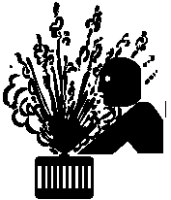
- Do not open the radiator cap while the engine is hot to avoid scalding injuries.
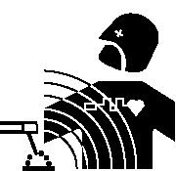
8.Electromagnetic：Welding current going though any area can generate electromagnetic, as well as the welding equipment itself.
- Electromagnetic would affect cardiac pacemaker, the cardiac pacemaker users should consult one’s doctor first.
- The effect of electromagnetic to one’s health is not confirmed, and it might have some negative effect to one’s health.
  - Welders may use following method to reduce the hazardous of electromagnetic:
a. Bundle the cable connected to the work piece and the welding cable together.
b. Do not enwind partially or entirely your body with the cable.
c. Do not place yourself between the welding cable and the ground (work piece) cable, if the welding cable is by your left side, then the ground cable should be by your left side too.
d. The Welding cable and the ground cable are as short as possible.
e. Do not work near to the welding power source.


9.Lifting equipment：Carton or wooden boxes package the welding machines supplied by Huayuan. There is no lifting equipment in its wrapper. Users can move it to the prospective area by a fork-lift truck, then open the box.

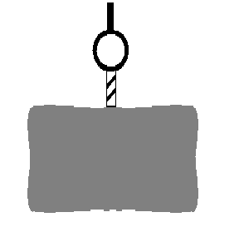
- If there are rings, the machine can be transited by rings. While Huayuan Welding Machine Manufacture reminds users, there is potential risk to damage the welding machine. So it is better to push the welding machine by its rollers unless special situations.
- Be sure that the appurtenances are all removed off when lifting.
- When lifting, make sure that there is no person below the welding machine, and remind people passing by at any moment.
- Do not move the hoist too fast.
- After the welding machine is installed in place, it should be carefully installed by professionals according to the relevant chapters of the instruction manual.
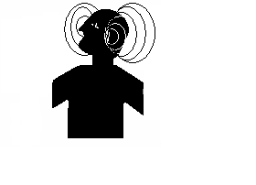
10.Noise：Huayuan Welding Machine Manufacture reminds users: Noise beyond the limit (over 80 db) can cause injury to vision, heart and audition depending on oneself. Please consult local medical institution. Use the equipment after doctor’s permission would help to keep healthy.

Catalogue
1、Product Overview 1
1.1 Model instruction 1
1.2 Main features 1
1.3 Usage 1
1.4 Symbol description 1
2、Working condition & Environment 2
2.1 Input Power 2
2.2 Environment 2
3、Specification and Parameter 3
4、System description 4
4.1 Working principal 4
4.2 Work circuit diagram： 4
5、Product structure description 5
5.1 Product composition 5
5.2 Front panel description and function 5
5.2.1 Digital display area: 5
5.2.2 Parameter adjust area: 6
5.2.3 Function selection area: 7
5.2.5 Storage and parameter selection area: 7
5.2.6 Protecting indicating area: 8
5.3 The rear panel description 8
5.4 Welding parameter control instructions 9
5.4.1 Parameter control mode setting 9
5.4.2 Remote control type setting 9
5.5 Secondary Menu Description 9
5.5.1 Secondary menu operation 9
5.5.2 Secondary menu functions and instructions 9
5.6 WSM Series analog communication interface description (special customization) 11
5.7 WSM Series RS485 Interface Description 12
5.7.1 RS485 Interface description 12
5.7.2 RS485 Configuration information and Modbus protocol specifications 13
5.7.3 Modbus Communication protocol address table 13
5.8 Detail drawing of the lower panel： 16
6、Installation 17
7、Operation: 18
8、Maintenance 18
9、Trouble Shooting: 19
10、Product completeness and accessories 20
11、Main Component List： 21
12、Attached Figure：Main Circuit Diagram of Product 26

1、Product Overview

Model instruction
WS(M) - XXXX HD pro
Product classification code
Rated welding current
Inverter DC (Pulse) TIG Welding Machine
Figure 1、Model instruction

Main features
WS(M)-HD series TIG welding machine adopts the high power IGBT and FRD as the breaker, the invert frequency reaches 20KHZ. The small mid-frequency transformer replaced the heavy industrial frequency transformer, which with advantages as: high efficiency, low non-load loss, stable current, energy saving, material saving and high reliability etc.
WS(M)-HD series TIG arc welding machine has all functions required by welding technique: high frequency arc striking, gas pre-send (adjustable), initial current (adjustable), current up-slope (adjustable), current down-slope (adjustable), crater current (adjustable), gas post-off(adjustable) etc.
Except for DC welding mode, the WSM-HD serials has pulsed welding mode, the advantage is: welding current high and low interchange working, so it has better arc and stronger weld seam which is decided by the welding machine parameter. The alternating high-low welding current reduces the duration of molten metal exposure to high temperatures, resulting in a finer grain structure and higher weld strength. Furthermore, by adjusting the four key pulse parameters, the weld bead profile can be precisely controlled, allowing the welding machine to determine the final surface morphology.

Usage
This series of welding machine can used for almost all metal work pieces except magnesium- aluminum alloy, such as stainless steel, pipeline, boiler, aerospace equipment etc.

Symbol description
 | Please read the manual |  | Input voltage
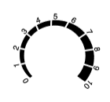 | Decrease/Increase parameters |  | Grounding symbol
 | Current (A) |  | Voltage (V)
 | OFF |  | ON
 | Positive output terminal |  | Negative output terminal
 | Fuse

2、Working condition & Environment

2.1 Input Power
  - The exact input voltage wave shape should be sine wave, the frequency fluctuation should be no more than +1% of the rated value；
  - The fluctuation of input voltage must be within +15% of the rated value;
  - The unbalance rate of input voltage should be ≦5%.

2.2 Environment
  - Ambient temperature ranges:Welding temperature range: -10℃~+40℃, Transportation and Storage temperature range: -25℃~+55℃
  - Relative humidity: ≤50% @ 40℃
≤90%@20℃
  - The dust, acid, corrosive gas or material around should not exceed the normal content, except the one produced during welding;
  - Operating altitudes: less than 1000m;
  - Wind speed should be no more than 1m/s;
  - Keep the machine inside and dry all the times, do not locate where the machine is exposed to direct sunlight and rain.

3、Specification and Parameter
Model  Item |  | WS-400HD pro | WSM-400HD pro | WSM-500HD pro
Input power |  | 3～ 380V±15％ 50／60 Hz
Rated Input Capacity (KVA) | TIG | 13.8 |  | 18.7
Rated Input Capacity (KVA) | MMA | 17.1 |  | 24.0
Rated Input Current (A) | TIG | 21 |  | 28.4
Rated Input Current (A) | MMA | 26 |  | 36.5
Rated Output Voltage (V) | TIG | 26 |  | 30
Rated Output Voltage (V) | MMA | 36 |  | 40
Rated Open Circuit Voltage (V) | TIG | 74 |  | 83
Rated Open Circuit Voltage (V) | MMA |  |  | 83
Power factor | TIG | 0.89 |  | 0.93
Power factor | MMA | 0.82 |  | 0.93
Energy efficiency class | - | 2 |  | 2
Efficiencyη | TIG | 85.3% |  | 85.6%
Efficiencyη | MMA | 88.5% |  | 88.1%
Rated Duty Cycle（%） |  | 60%
Hot Start Current Range (A) |  | 0～200
Arc Force Current Rage (A) |  | 0～200
Gas Pre-flow Time (S) |  | 0～10
Arc Striking Current Range (A) |  | 5～400 |  | 5～500
Current Up-slope Time (S) |  | 0～10
Welding current (A) |  | 5～400 |  | 5～500
Pulse Peak Current Range (A) |  | ／ | 5～400 | 5～500
Pulse Background Current Range (A) |  | ／ | 5～400 | 5～500
Pulse Frequency Range (Hz) |  | ／ | 0.2～99.9 | 0.2～99.9
Pulse Duty Ratio Range |  | ／ | 5%～95％ | 5%～95％
Current Down-slope Time Range (S) |  | 0～10
Crater Current Range (A) |  | 5～400 |  | 5～500
Gas Post-flow Time (S) |  | 0～20
Cooling mode |  | Air cooling
Isolation Grade |  | F
Ingress Protection |  | IP23S
Dimension (L*W*H) |  | 570×295×555 |  | 570×295×555
Net Weight (KG) |  | 33 |  | 34

4、System description

4.1 Working principal
WS(M)-HD series welding machine adopts IGBT as the main circuit switch. The three-phase AC input power inverted to 20KHz mid-frequency current through the rectify of the full bridge. This is followed by intermediate-frequency voltage reduction and rectification, then filtered and controlled via current negative feedback, ultimately outputting a continuously adjustable current that meets welding requirements.
The control circuit will control the output current through the adjusting of the pulse width. The negative feedback signal, which is the real welding current get from the output current sensor, put into the special PWM circuit after compared with the current adjust signal, then output the driving pulse to control the IGBT, so that the output current will keep stable to get descending external characteristic.
This machine has functions of gas pre send, gas post cut off, HF arc striking, current up-slope, current down-slope. All these functions are controlled by the digital signal controller automatically.

4.2 Work circuit diagram：
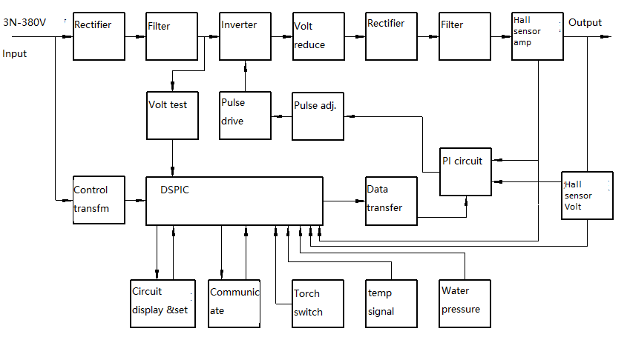

5、Product structure description

5.1 Product composition
This product is mainly composed of a core unit, housing, carrying handle, and support feet. The core unit consists of the following components: cooling fan，medium-frequency transformer，filter reactor，heat sink with high-frequency generator， igbt module，fast recovery diode rectifier module，control circuit board，etc.

5.2 Front panel description and function
The front panel divided to six area, as picture below：

Parameter adjust
Function select

Digital display
Protection

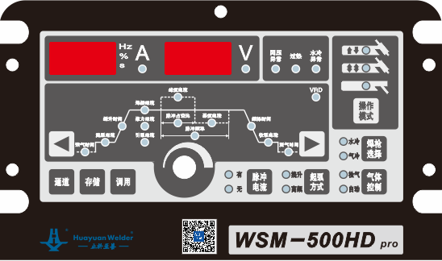

Panel diagram

5.2.1 Digital display area:


A
C
D
B

A.1st digital display meter: it is used to display welding/preset current, pulse/AC frequency, pulse width ratio/clean width, pre-gas time etc.
B.Display type indicator of 1st digital display meter: when the 1st digital display meter is displaying welding current, this indicator is on.
C.2nd digital display meter: it is used to display welding voltage, pass no. etc.
D.Display type indicator of 2nd digital display meter: when the 2nd digital display meter is displaying voltage, this indicator is on

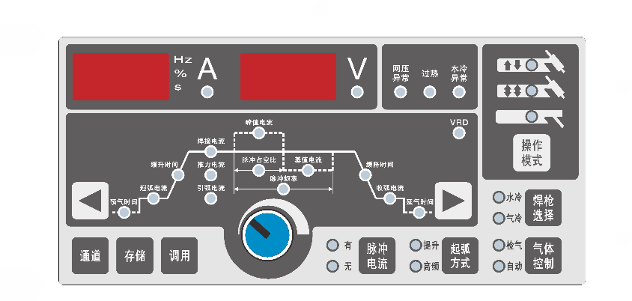
5.2.2 Parameter adjust area:

Q
P
O
N
M
L
K
J
I
H
G
F
E
D
B
A
C

At one time, there is only one indicator light on in this area, which indicates current displayed & adjusted parameter, and the parameter value is displayed on 1st digital display meter, adjusted by encoder. Display the welding current in default; When work as MMA or TIG without pulse, it displays the welding current, when work with pulse, it displays the peak current in default.
The current displayed or adjusted parameter can be selected through pressing the left or right selection key.
    - Left selection key: press the key, the lighted parameter indicator will move to left, it moves one after press key one time;
    - Gas pre-flow time: adjusting the gas pre-flow time;
    - Arc striking current: it is the current when the arc is started;
    - Up-slope time: current is transited from arc striking current to welding current(when there is no pulse)/peak current and base current (when there is pulse)time;
    - Welding current: it is the current when there is no pulse working;
    - Arc force current: the arc force current of MMA;
    - Hot start current: the hot start current of MMA;
    - Rotary encoder: it is used to adjust current displayed parameter；
    - PWM ratio: when there is pulse working, the ratio between peak current time and pulse cycle; only MULTIG has this function;
    - Pulse frequency: when there is pulse working, it is pulsed working frequency (the inverse of pulse cycle), only MULTIG has this function;
    - Peak current: it is pulsed peak current when there is pulse working; only MULTIG has this function;
    - Base current: when there is pulse working, it is the base current of pulse, only MULTIG has this function;
    - Down-slope time: the time of current transited from welding current(pulse on)/peak current and base current(pulse off) to crater arc current;
    - Crater arc current: the current during the arc ending;
    - Gas post-flow time: it is gas post-flow time;
    - Right selection key: press the key, the lighted parameter indicator will move to right, it moves one after press key one time.
    - VRD indicator：The machine output safety voltage when this indicator on

5.2.3 Function selection area:
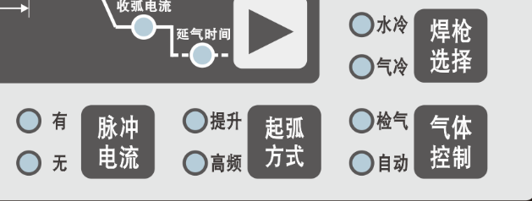

D
C
B
A

    - WS－HD：welding current indicator of remote control/local control, to select control the current in local or remote;
WSM－HD：pulse on/off indicator: To select the pulse on or off;
    - Arc striking mode indicator: to indicate the arc striking mode: high frequency arc striking or lifting arc striking;
    - Gas control and indicator: shift on the position of “gas checking”, to adjusting the argon flow, after adjusting, shift to “automatic” position, then the welding machine feed gas and cut off gas automatically;
    - Torch selection key and indicator: when use air cooling welding torch, it should be “air cooling” position, when use water cooling welding torch, it should be “water cooling” position, and start the water pressure checking function.
5.2.4 Function select area:
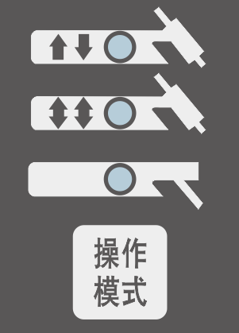
A

B

C

D

    - Two steps: when this indicator is on, the welding machine is the non self-lock status of TIG welding;
    - Four steps: when this indicator is on, the welding machine is the self-lock status of TIG welding;
    - MMA: when this indicator is on, the welding machine is working as MMA;
    - Function select selection key: this key is used to shift the Function selects of welding machine.

5.2.5 Storage and parameter selection area:


A
C
B

    - Channel key: first time press the: “channel key”, the voltage meter displays the present channel number, the current meter displays the present present stored welding parameter; Press the right/left selection key to display other stored parameters; Press the “storage” key to store the present welding parameter to the channel; Press “parameter selection” key to select a stored parameter to use; Press “Channel” key to turn to next channel; It quits the channel if there is no action within 5 seconds.
    - “Storage” key: to store the present welding parameter to the present channel;
    - “Parameter selection” key: to select a stored parameter to use;

5.2.6 Protecting indicating area:
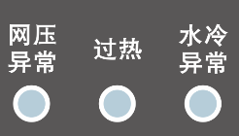

B
A
C

    - Input abnormal indicator: this indicator lights on when input voltage higher than 380±15% range or lack phase;
    - Over-heating indicator: when the temperature inside the machine is too high, this indicator lights on;
    - Water cooling abnormal indicator: when use water cooling welding torch, it shows the water pressure status; when the water pressure is low, this indicator lights on.

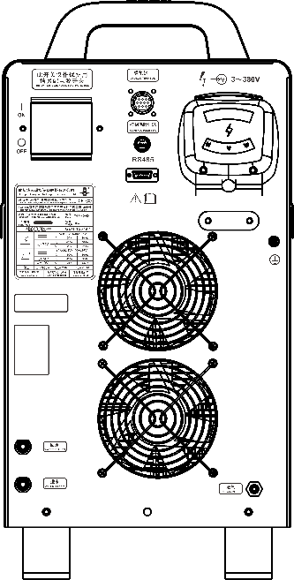
5.3 The rear panel description

I
A

B
H

C

D

E
G
F

The rear panel of HD pro
    - Power protection switch: this switch is only for overcurrent protection, please make another power switch separately;
    - Power lead: the three phase power cable is fixed on the machine by screwed union;
    - Name plate position;
    - Air cooling fan;
    - Water inlet;
    - Water outlet;
    - Air inlet: to connect with the argon gas reducing valve;
    - RS485 communication interface (standard for WSM series)；
    - Analog Communication Interface: This interface features remote control input, start signal input, and outputs for current signal, arc ignition success signal, and arc voltage signal (optional for WSM series).

5.4 Welding parameter control instructions

5.4.1 Parameter control mode setting
There are two control methods for the panel parameters of the welding machine: local control and remote control. Different application conditions allow for the arbitrary selection of one control method to control the operation of the welding machine. Remote control includes analog communication control and RS485 communication control, and the parameter control mode can be set through the secondary menus 1 and 7.
① Local control, the panel parameters of the welding machine can only be adjusted through the adjustment knobs and buttons on the panel, but all parameters of the welding machine can be transmitted to external monitoring devices through the RS485 interface.
② Remote control, users can connect to the RS485 interface or analog interface of the welding machine through external monitoring equipment, set welding parameters through the external monitoring equipment, and the welding machine panel only displays the adjustment parameters of the external monitoring equipment.

5.4.2 Remote control type setting
When the secondary menu number is 7, the function selection of this menu item is as follows:
0：all parameters are adjusted on the welding machine panel in this state;
1：all parameters in this state are controlled and adjusted by remote control equipment;
2：in this state, the remote control equipment sends the adjustment range to the welding machine, and the welding machine can be adjusted within this range;
3：enable analog communication. In MMA (Manual Metal Arc) mode, the welding current is adjusted by the remote control signal, while the thrust current and arc starting current are adjusted on the welder panel. In DC TIG mode, the welding current is adjusted by the remote control signal, and all other parameters are adjusted on the welder panel.

5.5 Secondary Menu Description

5.5.1 Secondary menu operation
Long press the "Parameter select" button for 5 seconds to enter the secondary menu settings. After entering the secondary menu, the ammeter displays the function number and the voltmeter does not display. Select the function number through the rotary encoder, press “Function select” after selecting the function number, then adjust the parameter values of the corresponding function number through the rotary encoder, press “Function select” to save and exit the secondary menu.

5.5.2 Secondary menu functions and instructions
Function Number | Function Name | Selection Range | Default Value | Remarks
0 | Current upslope adjustment | 10～60A | 60
1 | × | × | × | ×
2 | Remote pot calibration |  |  | See details on 7.5

3 | VRD disable indicator | 0 / 1 | 0 | 0:Enable  1:Disable
4 | Form factor | 0～5 | 0
5 | Ramp up/down mode | 0 / 1 | 0 | 0:Huayuan Standard Ramp  1: Legacy Ramp
6 | Short-circuit detection enable | 0 / 1 | 0 | 0:Disable Short-Circuit Detection  1：Enable Short-Circuit Detection
7 | Control mode | 0:Local Control | 0 | All parameters are adjusted locally on the welder panel.
7 | Control mode | 1:RS485 Remote Control | 0 | All parameters are controlled by remote device.
7 | Control mode | 2:RS485 Range Delegation | 0 | In this mode, the remote device defines adjustable parameter ranges which are then fine-tuned locally on the welder.
7 | Control mode | 3:Analog Signal Control | 0 | In this mode, the welding current and start stop signal are controlled and regulated by remote control equipment.
8 | Machine ID | 1～247 | 20 | ModbusSlave Address
9 | Baud rate | 0～4 | 1 | 0: 9600 bps  1：19200 bps  2：38400 bps  3：57600 bps  4：115200 bps
50 | Equipment serial No. | × | × | In the secondary menu mode, only the welding machine number is displayed and cannot. be changed by the user

51 | Software version | × | × | In the secondary menu mode, only the software version number is displayed and cannot be changed by the user

5.6 WSM Series analog communication interface description (special customization)
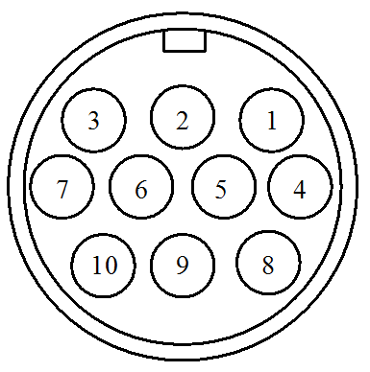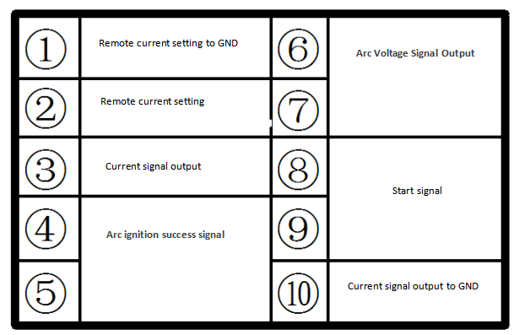
Welder Rear Panel Analog Communication Interface Diagram
- Pin：Remote control power setting to GND
- Pin：Remote current setting, the factory default configuration requires a DC voltage input of 9V to achieve rated output status.(relative to ① Pin remote control power supply GND)
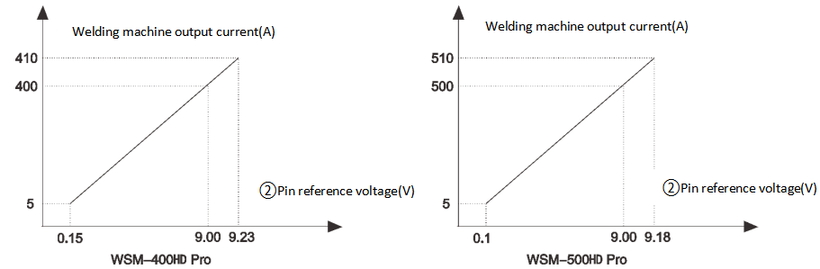
According to user needs, the given range of remote control current can be adjusted by oneself. The specific operation is as follows:
1）Set the remote control enable flag (enable remote control analog communication);
a.Press and hold the “Recall" button for 5 seconds until only the current meter displays, then release.
b.Use the encoder to adjust the current meter display to "7", then press the "Function select"button once.
c.The voltage meter will display 0, while the current meter shows the current control mode "3" = analog communication disabled. Use the encoder to select "Remote Enable Flag = 3", then press "Function select" to confirm.
d.he system will reboot automatically. Setup complete.
2）Remote Voltage Calibration:
a.Press and hold "Recall" for 5 seconds until only the current meter displays, then release;
b.Use the encoder to adjust the current meter display to "2", then press "Function select" once;
c.voltage meter displaying "0"，Set minimum voltage at ② Pin (Recommended: 0.15V for 400A models / 0.1V for 500A models). Press "Function select" to confirm;
d.voltage meter displaying 1，Set maximum voltage at ② Pin (Do not exceed 10V). Press "Function select" to confirm.
e.The system will reboot automatically. Calibration complete.
Note: After calibration,minimum voltage at ②Pin corresponding minimum output current,maximum voltage at ②Pin corresponding maximum output current.
3）Remote Function Usage:
a.When remote control is disabled, all parameters are adjusted on the welder panel;
b.When remote control is enabled，in MMA mode，remote signal controls welding current; thrust & arc-start currents remain panel-adjustable；In DC TIG mode，remote signal controls welding current; other parameters are panel-adjusted.
③&⑩Pin: Current signal analog output, welding machine outputs different voltage values under different current output states.（output GND for the current signal of ⑩Pin）。the specific linear relationship is as follows：
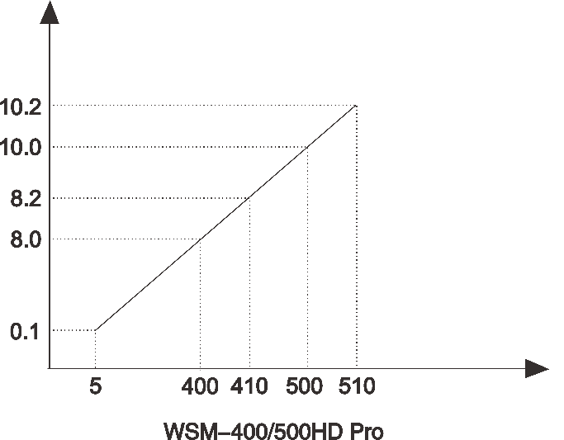
Welding machine output current(A)
③Pin corresponding output voltage(V)
④&⑤Pin：Arc ignition success signal output，this output consists of a relay contact set that closes upon successful arc ignition. It has a rated load capacity of 0.3A/125VAC or 1A/30VDC for direct control applications.
⑥&⑦Pin：(⑥Pin positive) with a 10:1 scaling ratio between actual arc voltage and output signal (e.g. when the arc voltage at the welder's output terminals is 26V, the corresponding signal output will be 2.6V).
⑧&⑨Pin：Start signal, the welding machine starts when short circuited and stops when disconnected.

5.7 WSM Series RS485 Interface Description

5.7.1 RS485 Interface description
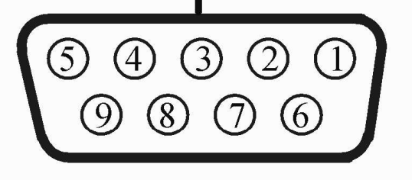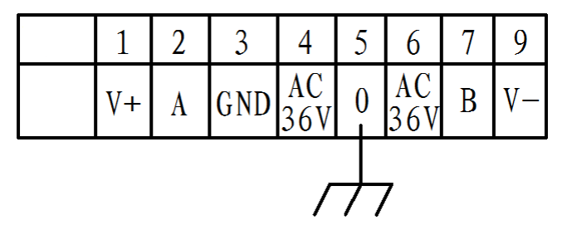
Line
number
Pin
Welding machine communication interface diagram

Pin number | Signal name | Function | note
1 | +12VDC | Power supply to external devices, maximum output power of 10W | note1
2 | RS485 A | RS485 A signal | note2
3 | GND | RS485 bus GND
4 | AC36V | Power supply to the analog communication box, AC 36V | note3

5 | Shielding wire | Shelled with PE, when using shielded wire, the shielding layer is connected to this pin.
6 | AC36V | Power supply to the analog communication box, AC 36V | note3
7 | RS485 B | RS485 B signal | note2
9 | +12VGND | Power supply to external devices, maximum output power of 10W | note1
Interface note description:
Note 1: Not connected during normal production; When the welding machine needs to add group control function, ①pin should be connected to V+, ②pin should be connected to V -;
Note 2: To ensure reliable RS485 communication, please use high-quality twisted pair shielded cables.
Note 3: This AC power supply is a dedicated power supply for analog communication boxes and cannot be used for other purposes.

5.7.2 RS485 Configuration information and Modbus protocol specifications
① 8-bit data bit, 1-bit stop bit, no parity check;
② The baud rate can be selected from 9600, 19200, 38400, 57600, and 115200, with a default of 19200;
③ The register address in the communication protocol address table does not distinguish between PLC address and register. The decimal data in the Modbus protocol address table is the register communication address;
④ Register addresses not listed in the communication protocol address table are considered illegal addresses and cannot be read or written, otherwise an error will be reported;
At most, it can read and write up to 10 consecutive registers.

5.7.3 Modbus Communication protocol address table
Serial number | Communication data | Register address  (Decimal)） | Data Range  (Decimal) | Note | Data attributes
 | Welder serial number | 41000 | 0～99 | 1st and 2nd digits | Read only data, supports 03 function code
 | Welder serial number | 41001 | 0～99 | 3rd and 4th digits | Read only data, supports 03 function code
 | Welder serial number | 41002 | 0～999 | 5th, 6th and 7th digits | Read only data, supports 03 function code
 | Welder serial number | 41003 | 0～99 | 8th and 9th digits | Read only data, supports 03 function code
 | Welder serial number | 41004 | 0～99 | 10th and 11th digits | Read only data, supports 03 function code
 | Firmware version | 41005 | 0～99 |  | Read only data, supports 03 function code
 | Firmware version | 41006 | 0～99 |  | Read only data, supports 03 function code
 | Actual current | 41020 | 0～999 | Unit：A，Magnification：1 | Read only data, supports 03 function code
 | Actual voltage | 41021 | 0～999 | Unit：V，Magnification：0.1 | Read only data, supports 03 function code
 | Arc ignition success signal | 41022 | 0～1 | 0：Failure to initiate arc or unsuccessful arc initiation  1：initiate arc successfully | Read only data, supports 03 function code
 | Error code | 41023 | 0～999 | Reference fault representative code | Read only data, supports 03 function code
 | Max channel number | 41024 | 9 | Number of welding machine channels | Read only data, supports 03 function code

 | Start/stop signal | 42000 | 0～1 | 0：stop welding  1：start welding | Control class reading and writing data, supporting 03, 06, and 10 function codes
 | Gas check function | 42001 | 0～1 | 0：cancel（automatic）  1：ventilation（Check the gas）
 | Parameter select | 42005 | 0～9 | 0：launch recall  Not 0：corresponding channel number recall
 | storage | 42006 | 0～9 | 0：without  Not 0：Store in the corresponding channel number
 | Parameter control mode | 42010 | 0～2 | 0: Welding parameters are controlled by the welding machine itself  1: Welding parameters are controlled by external equipment and cannot be adjusted by the welding machine  2: The welding machine parameters are provided with an external adjustment range, and the welding machine can adjust the parameters within this range
 | Torch cooling mode | 42020 | 0～1 | 0: Air cooling  1: Water cooling
 | Local control mode | 42021 | 0～1 | 0: Near control  1: Remote control
 | VRD disable flag | 42022 | 0～1 | 0: Enable  1: Disable
 | Channel data status | 43000 | 0～1 | 1: Channel data is empty  0: Channel data is normal | Non control type read and write data, supporting 03, 06, and 10 function codes
 | Set current | 43001 | WS(M)-400HD： TIG：5-410 MMA：8-410 WS(M)-500HD： TIG：5-510 MMA：8-510 | Unit：A，multiplier：1
 | Initial current | 43003 | reference set current range | Unit：A，multiplier：1
 | Crater current | 43005 | reference set current range | Unit：A，multiplier：1
 | (Dual) pulse frequency | 43011 | 2～999
 | Torch mode | 43014 | 0～2 | 0：two steps  1：four steps  2：MMA
 | Welding type | 43015 | 0～1 | 0：MMA  1：DC welding
 | Current upper limit | 43016 | reference set current range | the upper limit value must be greater than the lower limit value
 | Current lower limit | 43017 | reference set current range
 | Initial current upper limit | 43020 | reference set current range
 | Initial current lower limit | 43021 | reference set current range
 | Crater current upper limit | 43024 | reference set current range
 | Crater current lower limit | 43025 | reference set current range
 | Current ramp-up time | 43033 | 0～100 | Unit：s multiplier：0.01
 | Current ramp-down time | 43034 | 0～100 | Unit：s multiplier：0.01
 | Gas pre-flow time | 43040 | 0～100 | Unit：s multiplier：0.1
 | Gas post-flow time | 43041 | 0～200 | Unit：s multiplier：0.1
 | (Dual) pulse duty cycle | 43048 | 10～90
 | Pulse background current | 43049 | reference set current range | Unit: A multiplier: 1
 | Pulse peak current | 43053 | reference set current range | Unit: A multiplier: 1
 | Arc starting mode | 43070 | 0～1 | 0：High frequency arc starting  1：Lift arc starting
 | Pulse current output switch | 43071 | 0～1 | 0：without pulses  1：with pulses
 | Lift current adjustment | 43072 | 10～60 | Unit: A multiplier: 1
 | Waveform factor | 43073 | 1～5
 | Ramp up/down mode | 43074 | 0～1 | 0:Huayaun standard ramp  1:legacy linear ramp
 | Thrust current | 43075 | 0～200 | Unit: A multiplier: 1
 | Arc starting current | 43076 | 0～200 | Unit: A multiplier: 1
 | Thrust current upper limit | 43077 | reference set current range | the upper limit value must be greater than the lower limit value
 | Thrust current lower limit | 43078 | reference set current range
 | Arc starting current upper limit | 43079 | reference set current range | the upper limit value must be greater than the lower limit value
 | Arc starting current lower limit | 43080 | reference set current range
 | Peak current upper limit | 43081 | reference set current range | the upper limit value must be greater than the lower limit value
 | Peak current lower limit | 43082 | reference set current range
 | Background current upper limit | 43083 | reference set current range | the upper limit value must be greater than the lower limit value
 | Background current lower limit | 43084 | reference set current range

5.8 Detail drawing of the lower panel：
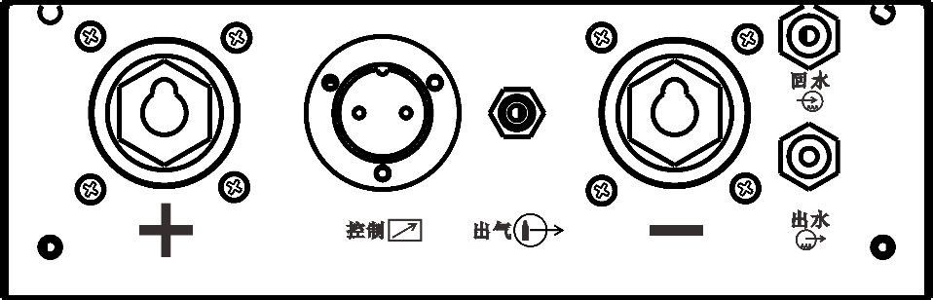

F
E
A
B
C
D

- Connect workpiece；
- Connect the welding gun switch plug；
- Argon gas output nozzle；
- Connect welding gun；
- Connect the water-cooled welding gun return nozzle；
- Connect the water-cooled welding gun nozzle。

6、Installation
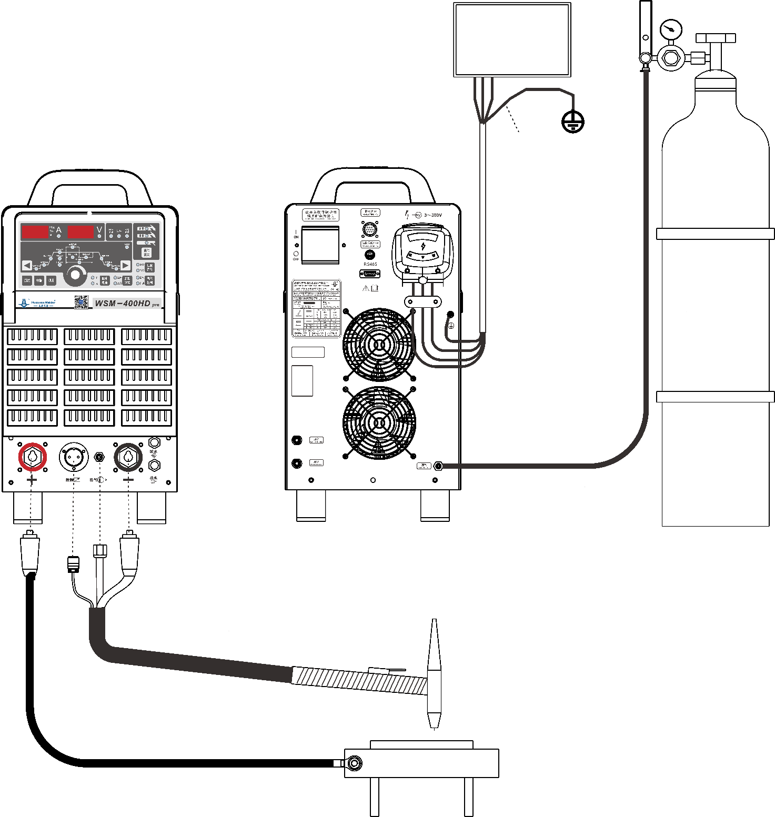
Green-yellow dual
color line
Three phase
power switch box
Welding torch
Workpiece
Gas cylinder
Three phase power line
(user provided)
6.1 The power supply of this machine is 3~380V 50/60HZ, user should prepare the switchboard and install the air switch (breaker) and ground cable. Connect the green-yellow wire of the three-phase input cable to the grounding wire on the switchboard reliably according to the below table:
Item  Model | Sectional area of power cable (mm²) | Air switch (A) | Sectional area of ground cable (mm²)
WS(M)-400HD pro | ≥4 | 40 | ≥50
WSM-500HD pro | ≥6 | 60 | ≥50

6.2 Connect the argon gas to the air inlet through reducing valve (Use Ф8 air hose)；
6.3 Connect the cooling water to the water inlet on the rear of the machine. !!! Note: The machine inside does not need the cooling water but the water cooling welding torch, so only when use water cooling welding torch, the water can be connected in；
6.4 When work as Tig, connect “+” terminal to work-piece firmly; when work as MMA, connect the “+” terminal according to different electrode；
6.5 Welding torch connection: Air cooling torch: connect the torch air hose with the “air outlet “on the welding machine, connect the torch control plug with the “control“on the welding machine, connect the main cable with “-” terminal on the welding machine; water cooling torch: it’s all the same as the air cooling torch, but the water cooling hose is connected outside of the welding machine.

7、Operation:
7.1 Turn on the power switch, the welding machine start to check by itself, the digital meters and indicators on panel lights on together for 1.5 seconds and lights off 0.5 seconds, then display normally；
7.2 Press the “Gas control” key, the “check gas” indicator lights on, adjust the argon gas flow according to different welding technology, then press “gas control” key again and the “automatic” indicator lights on；
7.3 Set the “pulse on/off” according to different welding technology, press the “Pulse current” key to do that. If choose “pulse off”, set the welding current by adjusting the encoder; if choose “pulse on”, set the “peak current”, “PWM ratio”, “Pulse frequency” and “base current”, press left/right selection key to choose the parameters need to be set；
7.4 Set the “gas pre-flow time”, “arc starting current”, “Up-slope time”, “down-slope time”,”crater current” and “gas post-flow time” according to different welding technology；
7.5 Welding operation：
7.5.1Two steps: take the tungsten electrode close to the work-piece about 1~3mm, press the welding torch switch without loosen, it starts weld normally after current up-slope, when finish welding, loosen the welding torch switch, the current down-slope to crater current. After welding, please don’t take away the welding torch at once, should wait the gas post-flow time finish, to protect the weld crater and tungsten electrode；
7.5.2Four steps: take the tungsten electrode close to the work-piece about 1~3mm, press the welding torch switch without loosen, after arc striking, find the welding position, then loosen the welding torch switch, the welding current will increase to the set current, it starts weld normally , when finish welding, press the welding torch switch again, the current down-slope to crater current, loosen the torch switch, arc stop and the welding finish. After welding, please don’t take away the welding torch at once, should wait the gas post-flow time finish, to protect the weld crater and tungsten electrode；
7.6 MMA: connect the work-piece too “+’”-” according to different welding technology; after connecting the ground cable and electrode holder, set the welding current/arc force current/hot starting current according to electrode diameter; before welding, the welding machine output 20V～28V DC voltage, when the instant moment that electrode touch the work-piece, the welding machine output welding current and start the normal welding, after arc stop, the open circuit voltage will remain 1 second.

8、Maintenance
For safety, the welding machine should be maintained and checked regularly, when check the inner or outside connecting terminals, do cut off the power distribution box( or the breaker).
8.1 Daily notes：
  - Check if there is any abnormal voice, vibration or smell；
  - Check if there is abnormal heating on the joint of cables；
  - Check if the cooling fan of the welding machine rotating flexibly when the power switch is turned on；
  - Check if the cable is broken or not.
8.2 Checking items in 3~6 months period：
  - The electrical connection: check the fastening screws on cables, to find if there is any loosen, rust or poor connecting and so on;
  - Grounding cable: check if the welding machine is grounded well.
8.3 Clean the dust inside the machine:
This work should be done every half a year, remove the side panels and top cover, and use dry compressed air to remove dust from the relevant parts.
8.4 Adjust the high frequency:
Never touch the spark electrodes (the distance of the spark electrodes should be 1mm), when the electrode surface is rough or polluted, polish it. Before touching the electrodes, please discharge them, and then adjust the distance to 1mm.

9、Trouble Shooting:
Problem | Possible reasons | Trouble shooting
- When machine energized, the circuit breaker trip | Three phase bridge rectifier was may damage | Replace the rectifier；
- When machine energized, the circuit breaker trip | IGBT damage | Replace IGBT
- No output current | The control fuse on the back may broken | Replace fuse 1.5A
- No output current | Cooling fan not work, or overload cause overheat, then temperature relay protect | Repair the cooling fan and do not overload
- No output current | Temperature relay may damage | Replace the temperature relay
- No Arc striking | Machine output terminal not connect reliably with the work piece | Reliably connect the work piece and output terminal
- No Arc striking | Torch trigger or plug wire may damage | Replace the torch trigger and well connect the plug
- There is no output voltage, but noise from the machine | FRD in welding machine main circuit may damage | Replace the FRD
- Difficult to strike arc | Workpiece too dirty | Clean the workpiece
- Difficult to strike arc | Tungsten quality not good or blunting | Replace good tungsten or sharpen it
- Cannot turn off the argon gas. | Program control board AP2 damage； | Repair AP2；
- Cannot turn off the argon gas. | There are substance in gas valve； | Clean the air valve
- Cannot turn off the argon gas. | Check gas/auto selection switch does not set to auto position； | Put the switch to auto position；
- Cannot turn off the argon gas. | The spring in the air valve may have elastic shortage | open the air valve and extend the spring
- No argon | The voltage of the air valve coil is insufficient or the coil was burnt | Check the coil voltage（~36V） or replace the air valve
- No argon | Program control board AP2 damage； | Repair AP2；
- There is burnt smell from the machine | Some components was burnet or there are wires short circuit. | Replace the damaged components or deal with the short circuit parts；
- Machine not work, but the overload indicator on | Machine overload | Stop welding, let the machine rest for 10min without load
- Machine not work, but the overload indicator on | Cooling fan damage | Replace cooling fan
- When use water cooling torch, machine not work, but the cooling water indicator on | Water pressure too low or no water let in | Connect water
 | The water checking switch damage | Replace the water checking switch
- Arc break during welding or the machine not work, but the lack voltage indicator on | The input lack-phase or lack voltage | Check three phase input

★★Note: if meet some problem can’t solve, please shut down immediately and notify our professional maintenance personnel for inspection as soon as possible. Do not disassemble or repair the machine without authorization.

10、Product completeness and accessories
Number | Name | quantity | Unit
1 | host | 1 | set
2 | Certificate of Conformity,Warranty Regulations | 1 | copy

11、Main Component List：
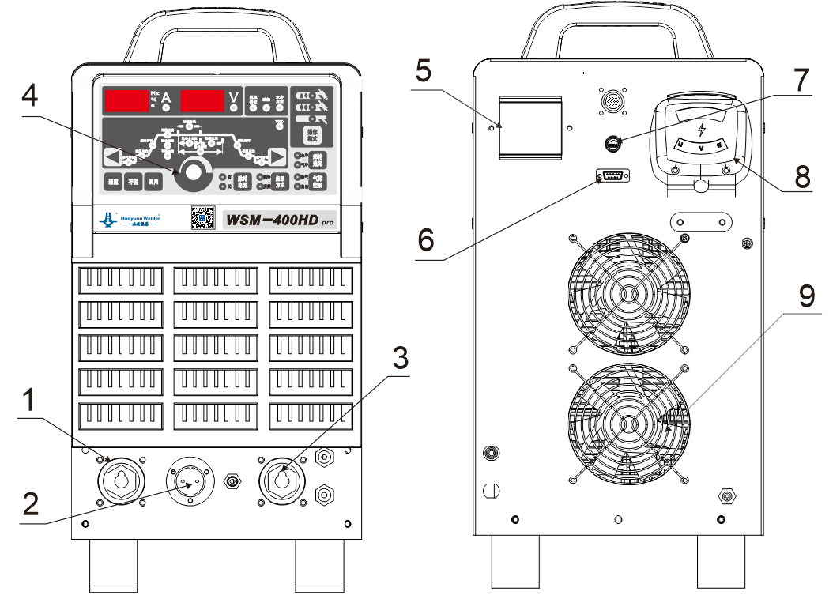
Front view Rear View
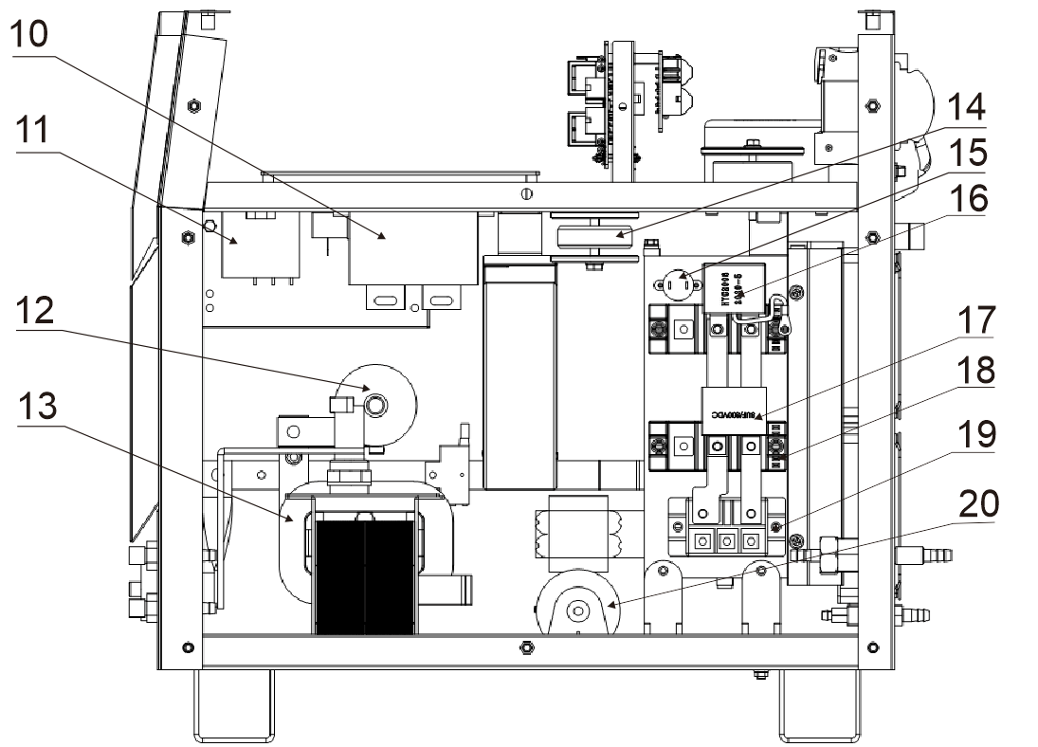
Right view
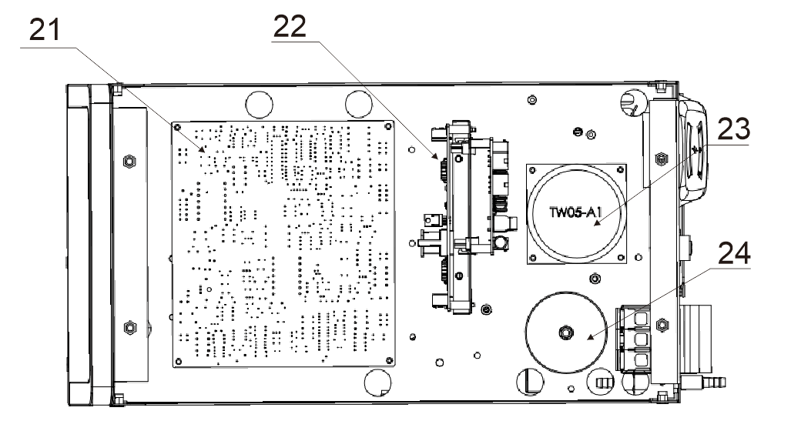
Vertical view
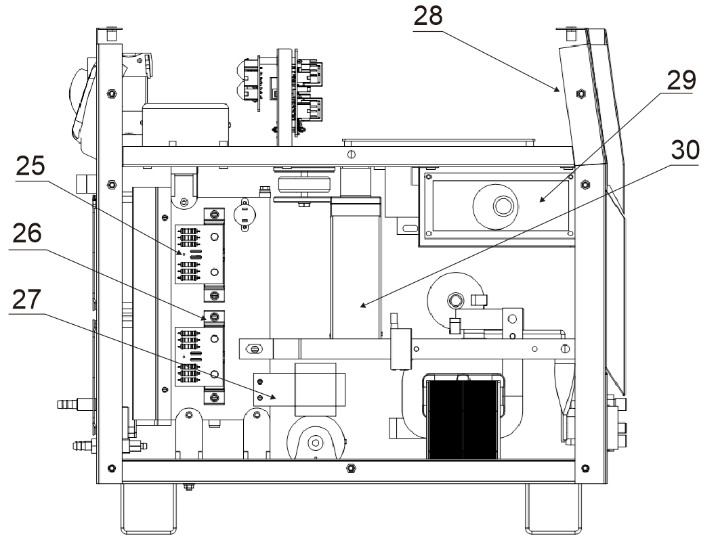
Left view

WSM-400HD pro-list of key components：
No. | Code | Name | Model specifications | Model code | Quantity
1 | X2 | Quick socket | DKJ-70 red | 104010000039 | 1
2 | SK1 | Control socket | 2 core socket | 104020000010 | 1
3 | X3 | Quick socket | DKJ-70 black | 104010000038 | 1
4 | XZ1 | Rotary encoder | RE1202BB1-H01-0003 | 102040000151 | 1
5 | QF1 | Air Switch | CDB6H-63 3P D type 40A | 102010200062 | 1
6 | SK2 | Serial port terminal socket | DB-9S | 104030000119 | 1
7 | FU1 | Insurance seat | F8-1（R3-12） | 102010300112 | 1
8 | X1 | Junction box | DFR-60 | 104010000021 | 1
9 | EV1、EV2 | Cooling fan | RD1238B24H-S（Line length400mm） | 103020000075 | 2
10 | C5 | Capacitance | HYC3001 | 102020503001 | 1
11 | C6 | Capacitance | HYC1002 | 102020501002 | 1
12 | THF1 | High frequency coupling coil | Self-made | 201051005 | 1
13 | L5 | Filter reactor | Self-made | 201050904 | 1
14 | L3 | Saturable reactor | Self-made | 201050903 | 1
15 | KT1、KT2 | Temperature relay | KSD305A normally closed75℃ | 102010400031 | 2
16 | C4 | Capacitance | HYC2008 | 102020502008 | 1
17 | C3 | Capacitance | HYC4006 | 102020504006 | 1
18 | V2,V3 | IGBT module | GD50HFF120C1SL | 102070100115 | 2
19 | V1 | Three Phase Bridge | MDS75D-12 | 102070300151 | 1
20 | C2 | Capacitance | 100μF/500VAC | 102020500004 | 1
21 | AP1 | Main control board | PW01 | 202050009 | 1
22 | AP4 | Drive board | PT05(18Ω） | 202090097 | 1
23 | TC1 | Control transformer | TW05 | 105010000356 | 1
24 | L1 | Amorphous iron core | 32×50×20 | 105020000002 | 1
25 |  | Fast recovery diode protection board | RCAP1 | 202980002 | 2
26 | V4、V5 | Secondary management module | MMF200ZB040DK1 | 102070200171 | 2
27 | L4 | linearity coil | Self-made | 201051002 | 1
28 | AP2 | Panel | PW02 | 202040026 | 1
29 | AP3 | High Frequency Board | HFAP1 | 202980003 | 1
30 | TM1 | Inverter transformer | Self-made | 201050901 | 1

WSM-400HD pro-list of key components：
No. | Code | Name | Model specifications | Model code | Quantity
1 | X2 | High frequency coupling coil | DKJ-70red | 104010000039 | 1
2 | SK1 | Filter reactor | Panasonic type2core | 104020000010 | 1
3 | X3 | Saturable reactor | DKJ-70black | 104010000038 | 1
4 | XZ1 | Temperature relay | RE1202BB1-H01-0003 | 102040000151 | 1
5 | QF1 | Capacitance | CDB6H-63 3P Dtype 40A | 102010200062 | 1
6 | SK2 | Capacitance | DB-9S | 104030000119 | 1
7 | FU1 | IGBT module | F8-1（R3-12） | 102010300112 | 1
8 | X1 | Three Phase Bridge | DFR-60 | 104010000021 | 1
9 | EV1、EV2 | Capacitance | RD1238B24H-S（Line length 400mm） | 103020000075 | 2
10 | C5 | Main control board | HYC3001 | 102020503001 | 1
11 | C6 | Drive board | HYC1002 | 102020501002 | 1
12 | THF1 | Control transformer | Self-made | 201051005 | 1
13 | L5 | Amorphous iron core | Self-made | 201050904 | 1
14 | L3 | Fast recovery diode protection board | Self-made | 201050903 | 1
15 | KT1、KT2 | Secondary management module | KSD305A normally closed75℃ | 102010400031 | 2
16 | C4 | Linearity coil | HYC2008 | 102020502008 | 1
17 | C3 | Panel | HYC4006 | 102020504006 | 1
18 | V2,V3 | High Frequency Board | GD50HFF120C1SL | 102070100115 | 2
19 | V1 | Inverter transformer | MDS75D-12 | 102070300151 | 1
20 | C2 | High frequency coupling coil | 100μF/500VAC | 102020500004 | 1
21 | AP1 | Filter reactor | PW01 | 202050009 | 1
22 | AP4 | Saturable reactor | PT05(18Ω） | 202090097 | 1
23 | TC1 | Temperature relay | TW05 | 105010000356 | 1
24 | L1 | Capacitance | 32×50×20 | 105020000002 | 1
25 |  | Capacitance | RCAP1 | 202980002 | 2
26 | V4、V5 | IGBT module | MMF200ZB040DK1 | 102070200171 | 2
27 | L4 | Three Phase Bridge | Self-made | 201051002 | 1
28 | AP2 | Capacitance | PW02 | 202040026 | 1
29 | AP3 | Main control board | HFAP1 | 202980003 | 1
30 | TM1 | Drive board | Self-made | 201050901 | 1

WSM-500HD pro-list of key components：
No. | Code | Name | Model specifications | Model code | Quantity
1 | X2 | Quick socket | DKJ-70red | 104010000045 | 1
2 | SK1 | Two core socket | Panasonic type2core | 104020000010 | 1
3 | X3 | Quick socket | DKJ-70black | 104010000044 | 1
4 | XZ1 | Rotary encoder | RE1202BB1-H01-0003 | 102040000151 | 1
5 | QF1 | Air Switch | CDB6H-63 3P Dtype 40A | 102010200063 | 1
6 | SK2 | Serial port terminal socket | DB-9S | 104030000119 | 1
7 | FU1 | Insurance seat | F8-1（R3-12） | 102010300112 | 1
8 | X1 | Junction box | DFR-60 | 104010000021 | 1
9 | EV1、EV2 | Cooling fan | RD1238B24H-S（line length 400mm） | 202840006 | 2
10 | C6 | Capacitance | HYC3002 | 102020503002 | 1
11 | C7 | Capacitance | HYC1002 | 102020501002 | 1
12 | THF1 | High frequency coupling coil | Self-made | 201051005 | 1
13 | L5 | Filter reactor | Self-made | 201051004 | 1
14 | L3 | Saturable reactor | Self-made | 201051003 | 1
15 | KT1、KT2 | Temperature relay | KSD305A normally closed75℃ | 102010400031 | 2
16 | C5 | Capacitance | HYC2001 | 102020502001 | 1
17 | C3、C4 | Capacitance | HYC4007 | 102020504007 | 2
18 | V2、V3 | IGBT module | GD50HFF120C1SL | 102070100177 | 2
19 | V1 | Three Phase Bridge | MDS100-12 | 102070300161 | 1
20 | C2 | Capacitance | 100μF/500VAC | 102020500004 | 1
21 | AP1 | Main control board | PW01 | 202050010 | 1
22 | AP4 | Drive board | PT05(13Ω） | 202090095 | 1
23 | TC1 | Control transformer | TW05-B1 | 105010000356 | 1
24 | L1 | Amorphous iron core | 32×50×20 | 105020000002 | 1
25 |  | Fast recovery diode protection board | RCAP1 | 202980002 | 3
26 | V4~V6 | Secondary management module | MMF200ZB040DK1 | 102070200171 | 3
27 | L4 | Linearity coil | Self-made | 201051002 | 1
28 | AP2 | Panel | PW02-B | 202040026 | 1
29 | AP3 | High Frequency Board | HFAP1-A3(WS/M) | 202980003 | 1
30 | TM1 | Inverter transformer | Self-made | 201051001 | 1

12、Attached Figure：Main Circuit Diagram of Product
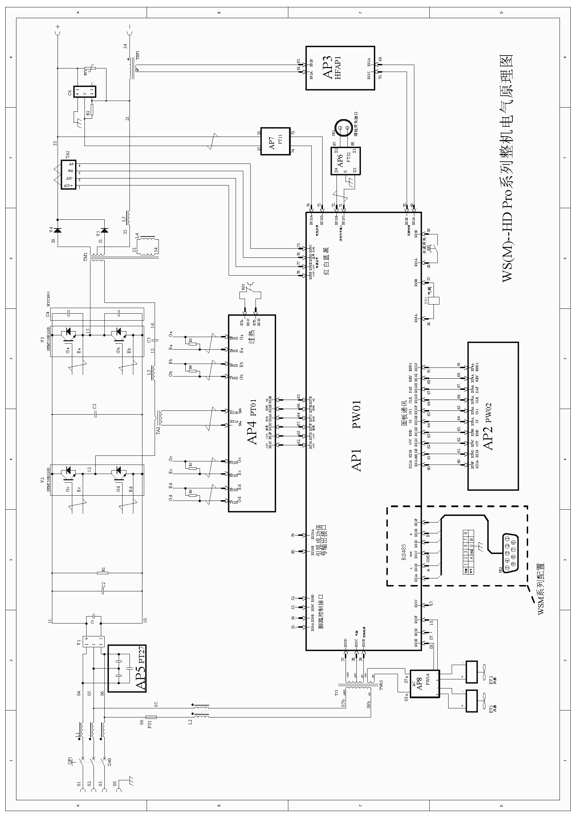

The final explanation rights reserved to Huayuan Company!
If there is any changes in the manual instruction, forgive not to inform separately!

Chengdu Huayuan Welding equipment Co.,Ltd.
Manufacturer:Chengdu Huayuan Electric equipment Co.,Ltd.
Address: No.1299 Konggang 2nd Road, Shuangliu Area,Chengdu,

After-sales Hotline：028-85805050
Web：www.hwayuan.com
E-mail: sales@hwayuan.com

